四年级英语试题
（时间：60分钟）
等级：
同学们，你们好！本次英语试题共分为两部分：听力部分和读写部分。听录音前要认真阅读题目要求，仔细观察图片。快来检测一下你有哪些收获吧！

Part I Listening 第一部分 听力
共六大题
I. Listen and choose. (听一听，选出你所听到的单词。)
( ) 1. | A. cat | B. hat |  | ( ) 2 . | A. notebook | B. storybook
( ) 3. | A. fan | B. candy |  | ( ) 4. | A. floor | B. door
( ) 5. | A. ear | B. near |  | ( ) 6. | A. light | B. night
( ) 7. | A. key | B. clean |  | ( ) 8. | A. map | B. make
( ) 9. | A. nice | B. ice |  | ( ) 10. | A. lot | B. note
II. Listen and number.（听一听，按照你所听到的顺序，给下列物品标上序号。）
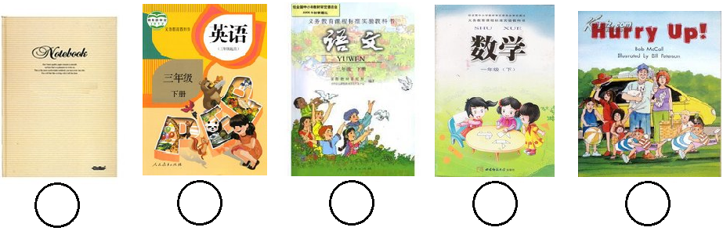
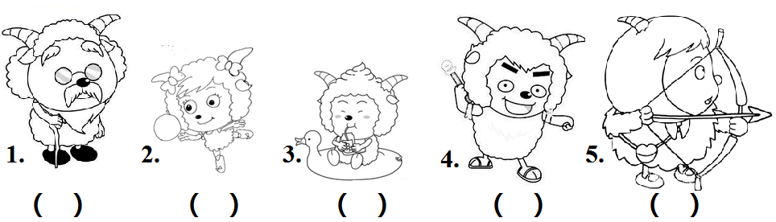
III. Listen and tick or cross. （听一听，判断下列图片是否正确，打“√”或“× ”。）
IV. Listen and match.（听一听，连一连。）
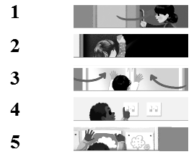
V. Listen and tick. (听一听，在你所听到的答语前打“√”。)
1. Where is the green book? 2. What’s his name?
( ) It’s near the window. ( ) His name is John.
( ) It’s on the floor. ( ) Her name is Sally.
3. What colour is it? 4. Who’s she?
( ) It’s blue. ( ) She’s Chen Jie.
( ) It’s white. ( ) He’s Wu Yifan.
VI. Listen and choose. （听一听，选择你所听到的单词补全短文。）
A. classroom B. on C. computer D. Where’s

We have a new . Let's go and see. Look! This is the new classroom. It’s big. The door is orange. The wall is blue. What’s in the classroom? One blackboard, one , one fan, many desks and chairs. the computer? It’s the teacher’s desk. I like my classroom!
Part II Reading & Writing 第二部分 读写
共五大题
VII. Find and choose. (找出与所给单词画线部分发音相同的单词。)
( ) 1. name A. make B. cat ( ) 2. cap A. cake B. map
( ) 3. rice A. pig B. nine ( ) 4. lot A. dog B. hope
( ) 5. six A. fine B. big
VIII. Read and match. (读一读，连一连。)
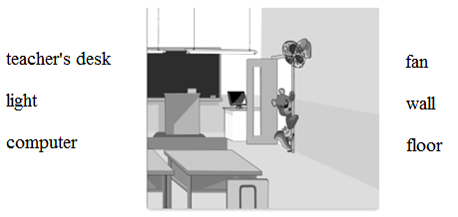
IX. Read and tick.（根据图片, 在正确的对话前打“√ ”。）
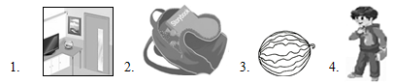
1. □A: Where’s the picture? B: It’s near the door.
□ A: Where’s the picture? B: It’s under the door.
2. □A: What’s in the schoolbag? B: A storybook and some candies.
□A: What’s in the schoolbag? B: A pencil and a ruler.
3. □A: What colour is it? B: It’s red and blue.
□A: What colour is it? B: It’s black and green.
4. □A: What’s his name? B: His name is Zhang Peng.
□A: What’s his name? B: His name is Mike.
X．Look, choose and write.（根据图片选择单词或句子，补全对话。）
Zhang Peng: Excuse me. I lost my schoolbag.
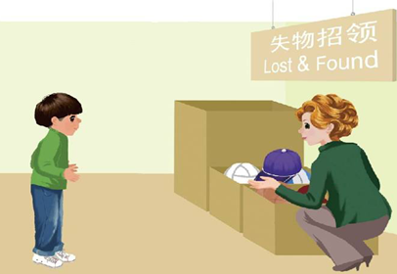
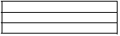
Miss White:
What’s in it?
What colour is it?
Thank you
a notebook

Zhang Peng: It’s blue and white.
Miss White: OK.
Zhang Peng: An English book, two
toys and .
Miss White: Here it is!
Zhang Peng: so much!
XI．Read and choose.（读短文， 选择正确的答案。）
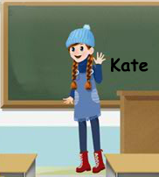
I have a good friend. Her name’s Kate. She's tall and thin. She has long hair and brown shoes. She likes maths. She's clever and quiet.
( ) 1. Kate is ____________.
A. tall and thin B. short and strong
( ) 2. Kate has ____________ hair.
A. long B. big
( ) 3. A: What colour are your shoes, Kate? B: ____________.
A. They’re white B. They’re brown
( ) 4. A: Do you like maths, Kate? B: ____________.
A. Yes, I do B. No, I don’t

一学期秋季质量检测
四年级英语试题（人教版）
同学们，你们好！本次英语试题共分为两部分：听力部分和读写部分。听录音前要认真阅读题目要求，仔细观察图片。快来检测一下你有哪些收获吧！
Part I Listening 第一部分 听力共六大题
I. Listen and choose. (听一听，选出你所听到的单词。)
1. cat 2. storybook 3. candy 4. floor 5. near
6. light 7. clean 8. make 9. nice 10. note
II. Listen and number.（听一听，按照你所听到的顺序，给下列书本标上序号。）
A: What’s in your schoolbag?
B: I have an English book, a notebook, a maths book, a storybook and a Chinese book.
III.Listen and tick or cross. （听一听，判断下列图片是否正确，打“√”或“× ”。）
- A: I have a friend. He’s old. He has black glasses.Who’s he?
B: His name is Man Yangyang.
2. A: I have a friend. She’s quiet. She’s a cute girl. Who’s she?
B: Her name is Mei Yangyang.
3. A: I have a friend. He’s thin. He has long hair.Who’s he?
B: His name is Xi Yangyang.
4. A: I have a friend. He’s strong. He has brown shoes.Who’s he?
B: His name is Fei Yangyang.
5. A: I have a friend. She’s friendly. She’s short.Who’s she?
B: Her name is Hong Tailang.
IV. Listen and match.（听一听，连一连。）
- Open the door. 2. Turn on the light. 3. Close the window.
- Put up the picture. 5. Clean the blackboard.
V. Listen and tick. (听一听，在你所听到的答语前打“√”。)
- Where is the green book? It’s on the floor.
2.What’s his name? His name is John.
3. What colour is it? It’s white. 4. Who’s she? She’s Chen Jie.
VI. Listen and choose. （听一听，选择你所听到的单词补全短文。）
We have a new classroom. let's go and see. Look! This is the new classroom. It’s big. The door is orange. The wall is blue. What’s in the classroom? One blackboard, one computer, one fan, many desks and chairs. Where’s the computer? It’s on the teacher’s desk. I like my classroom!

第一学期秋季质量检测
四年级英语（人教版）
评分标准及部分参考答案
听 力
I.（每小题1分，共10分）
A B B A B A B B A B
II. (每小题2分，共10分）
2 1 5 3 4
III.（每小题2分，共10分）
√√×√×
IV. (每小题2分，共10分）

V. (每小题3分，共12分）
下上下上
VI.（每个单词2分，共8分）
A C D B
读 写
VII.（每小题2分，共10分）
A B B A B
VIII.（每小题1分，共6分）略
IX.（每小题2分，共8分）
上上下下
X.（每小题2分，共8分）略
XI．（每空2分，共8分）
A A B A

