五年级英语试题（人教版）
（时间：60分钟）
等级：
同学们，你们好！本次英语试题共分为两部分：听力部分和读写部分。听录音前要认真阅读题目要求，仔细观察图片。快来检测一下你有哪些收获吧！

Part I Listening 第一部分 听力
共五大题
I. Listen and number.（听一听，排顺序。）
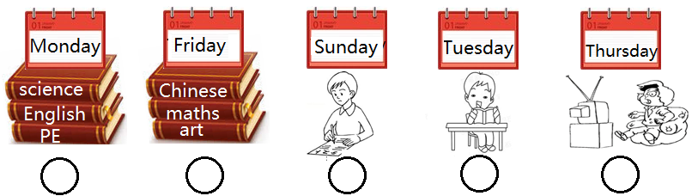
II. Listen, tick or cross.（听一听，判对“√”错“×”。）
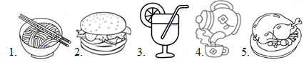
( ) ( ) ( ) ( ) ( )
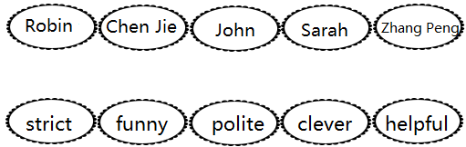
III. Listen and match. (听一听，连一连。)
IV. Listen and circle. (听一听，圈出你所听到的单词补全对话。)
John: Grandpa! Look at my picture.
Grandfather: Great! What do you have on (Thursdays/Sundays)?
John: I have maths, English and (sports/music).
Grandfather: Oh, I love music! Who’s your music (teacher/student)?
John: Mr Young.
Grandfather: Is he (kind/strict)?
John: No, he’s funny. What do you do on Thursdays, Grandpa?
Grandfather: Oh, I have a cooking (class/salad) with your grandma!
John: Haha!
V. Listen and choose. (听一听，选单词或短语补全对话。)
A. favourite B. noodles C. delicious D. food E. sandwiches

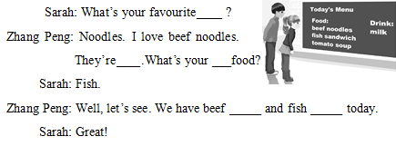
Part II Reading & writing 第二部分 读写
共五大题
VI. Group the words. (按照划线部分的发音把下列单词进行归类。)
yellow meet flower baby sunny eat down window
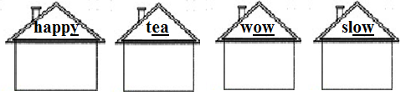
VII. Look and write. (读一读，写一写。)
sweet thirsty fresh healthy is are

- I’m . I’d like some water.
- A: What would you like to drink? B: Tea, please. It’s .
- A: What would you like to eat?
B: An ice-cream, please. It cool and .
- I’d like some oranges. They delicious and .
VIII. Copy the sentences. (抄写句子。)
1. Do you often watch TV on the weekend?

2. What do you have on Thursdays?

IX. Read and write . (读一读，填一填。)
Oliver: John, do you know Miss White?
John: No, I don’t know. Who is she?
Oliver: She’s my new English teacher.
John: Really? Is she old?
Oliver: No, she isn’t.
John: Is she strict?
Oliver: No, she isn’t.
John: What’s she like?
Oliver: She’s kind and polite.
1. Miss White is Oliver’s new ( English/PE) teacher.
2. Miss White is ( old/young) .
3. Miss White ( is/isn’t ) strict.
4. Miss White is ( shy/kind)and polite .
X. Read the dialogue and fill in the table, then tick or cross. (读对话，填表格并判正“√”误“×”。)
Chen Jie: David, what do you have on Mondays?
David: I have English, science, computer and maths in the morning. In the afternoon, I have PE and reading class.
Chen Jie: What’s your favourite class?
David: I like English. Hi, Jean. This is my new friend, Chen Jie.
Jean: Hi, Chen Jie. Nice to meet you!
Chen Jie: Nice to meet you, too!
David: Chen Jie is kind and clever. Her favourite class ia art.
Jean: Welcome to our class. We have art on Tuesday and Friday.
Chen Jie: What’s your favourite class, Jean?
Jean: PE class. I love sports.
Chen Jie: How many PE classes do you have in a week?
Jean: Let me see. Two. We have PE on Monday afternoons and Wednesday mornings.
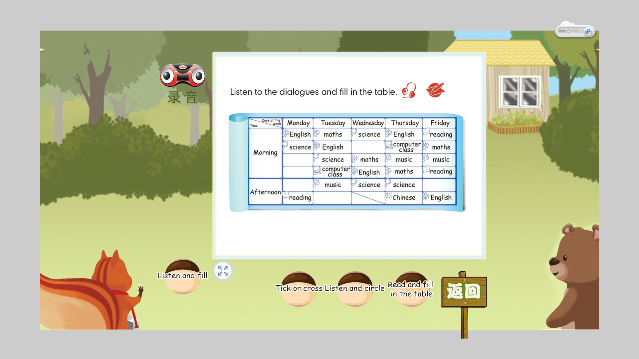
- Students have music and art on Tuesday afternoons. ( )
- David and Jean have two art classes on Fridays. ( )
- They have two PE classes in a week. ( )
4. Jean’s favourite class is reading class. ( )
第一学期秋季质量检测
五年级英语试题（人教版）
同学们，你们好！本次英语试题共分为两部分：听力部分和读写部分。听录音前要认真阅读题目要求，仔细观察图片。快来检测一下你有哪些收获吧！
Part I Listening 第一部分 听力
共五大题
I. Listen and number. (听一听，按照你听到的顺序为下列图片写出序号。)
1. A: What do you have on Mondays? B: I have science, English and PE.
2. A: Do you often read books on Tuesdays? B:Yes, I do. I like reading books.
3. A: Do you often watch TV on Thursdays? B:Yes, I do.
4. A: What do you have on Fridays? B: I have Chinese, maths and art
5. A: Do you often play football on Sundays?
B: No, I don’t. I often do homework.
II. Listen, tick or cross.（判断下图与你听到的内容是否相符，打“√”或“×”。）
1. My favourite food is noodles. It’s tasty.
2. I’d like a sandwich.
3. I like juice. It’s sour and fresh.
4. My favourite drink is tea. It’s healthy.
5. My favourite food is fish. It’s delicious.
III. Listen and match. (听一听，连一连。)
- What’s Robin like? Robin is strict.
2. What’s Chen Jie like? Chen Jie is polite.
- What’s John like? John is funny.
4. What’s Sarah like? Sarah is helpful.
5. What’s Zhang Peng like? Zhang Peng is clever.
IV. Listen and circle. (听一听，圈出你所听到的单词。)
John: Grandpa! Look at my picture.
Grandfather: Great! What do you have on Thursdays?
John: I have maths, English and music.
Grandfather: Oh, I love music! Who’s your music teacher?
John: Mr Young.
Grandfather: Is he strict?
John: No, he’s funny. What do you do on Thursdays, Grandpa?
Grandfather: Oh, I have a cooking class with your grandma!
John: Haha!
V. Listen and choose. ( 听一听，选单词或短语补全对话。)
Sarah: What’s your favourite food?
Zhang Peng: Noodles. I love beef noodles. They’re delicious.What’s your favourite food?
Sarah: Fish.
Zhang Peng: Well, let’s see. We have beef noodles and fish sandwiches today.
Sarah: Great!

第一学期秋季质量检测
五年级英语评分标准及部分参考答案
听力
I．（每小题2分，共10分）
1 4 5 2 3
II.（每小题2分，共10分）
√×√√×
III．（每小题2分，共10分）


IV.（每小题2分，共10分）
Thursdays music teacher strict class
V.（每空2分，共10分）
D C A B E
读 写
VI.（每个单词1分，共8分）
baby sunny; meet eat; down flower; yellow window
VII.（每个单词2分，共12分）
1. thirsty 2. healthy 3. is, sweet 4. are, fresh
VIII. (每小题4分，共8分）
1. Do you often watch TV on the weekend?
2. What do you have on Thursdays?
IX. (每小题2分，共8分）
1. English 2. young 3. isn’t 4. kind
X.（填表每空1分，判断每题2分，共14分）
    

